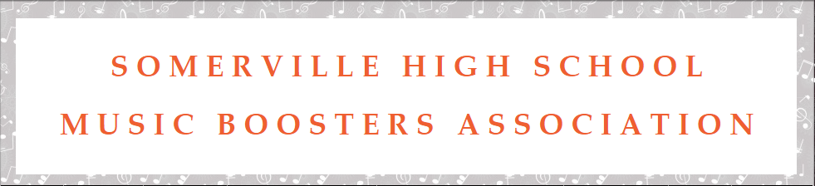

Somerville High School Music Boosters Association (SHSMBA) is a parent organization that devotes many volunteer hours supporting the music programs at Somerville High School. We will be holding our 12th Annual Tricky Tray Auction on Saturday, May 2, 2020. We are requesting products, gift certificates or financial donations. Donations are gratefully appreciated and are acknowledged in the event program. All proceeds from the event will allow us to continue to bring music to our children. Our tax ID number is 22-3686173.
If you are able, please support this wonderful cause. You may contact me, <insert your name> at <insert your email> or <insert your phone> should you have any questions. Donations may be sent to: SHSMBA, Somerville High School, 222 Davenport Street, Somerville, NJ 08876. We request that all donations be received by Friday, April 10, 2020.

Thank you in advance for your generous support.

Sincerely,
Your Name
Somerville High School
Music Boosters Association Representative

